Do you wake during the night due to pain?_______________________________________________________________________________
Hours/wk worked before accident________________________Hours/wk currently working________________________________
Is the accident under litigation?__________________________________________________________________________________________
Please check any that apply to you in relation to this accident:
( ) Numbness down arm ( ) Stiffness ( ) Difficulty swallowing ( ) Nausea ( ) Trembling
( ) Mood swings ( ) Dizziness ( ) Confusion ( ) Fatigue ( ) Depression
( ) Memory Loss ( ) Forgetful ( ) Unable to concentrate ( ) Anger ( ) Weakness
( ) Jaw Pain/Clicking ( ) Headaches ____________________________________________________________________________
Please list your areas of pain, starting with the most severe, using descriptive words below:
1.________________________________________________________ 2._______________________________________________________________
3.________________________________________________________ 4.________________________________________________________________
• throbbing •burning •aching •dull •tingling •shooting •stabbing •sharp
Is there anything you want to add that hasn’t been mentioned?_________________________________________________________
_____________________________________________________________________________________________________________________________
On the diagram, indicate area(s) affected by the accident:
X=Pain ////=Tightness B=Burning T=Tingling
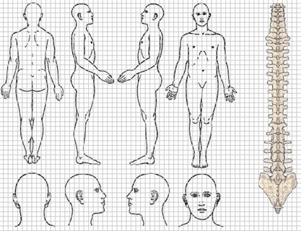

Fee Policy
In consideration for your fellow patients and your therapist, please allow a minimum of 24 HOURS NOTICE to change or cancel your appointment. You will be charged 100% of private fees for late cancellations or missed appointments. The patient (you) is responsible for all fees incurred for therapy. Please inform us if you are unable to make your appointment.
I understand the fee policy within this clinic. I authorize the clinic and its associated practitioners to collect my personal and medical information as documented above in order to contact me, and give permission for the ckinci to leave messages regarding appointments at any of the contact numbers I have provided. In addition, I authorize the clinic and its associated practitioners to communicate with my referring MD as deemed necessary for my beneficial treatment. I also inderstand that my personal and medical information is confidential and will only be disclosed to third parties with my permission.

Date:___________________________________ Signature:________________________________________________________________________

